How to upload file from user and save it into folder and database and also rename

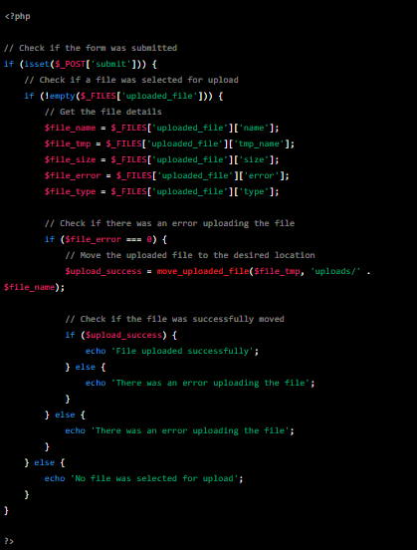

I want to change the name for image in image upload. Im using php mysql?
This is how you will do it.
$target_dir = "temporaryProfilePhoto/";
$target_file = $target_dir . basename($_FILES["uploadfile"]["name"]);
$imageFileType = pathinfo($target_file,PATHINFO_EXTENSION);
// $imgname = "abc.".$imageFileType;
$imgname = $CustomerNumber.".".$imageFileType;//it works
move_uploaded_file($_FILES["uploadfile"]["tmp_name"], $target_dir.$imgname);
;

FormData: FormData() constructor

new FormData()
new FormData(form)
new FormData(form, submitter)

form :

An HTML <form> element — when specified, the FormData object will be populated with the form's current keys/values using the name property of each element for the keys and their submitted value for the values. It will also encode file input content. A formdata event is fired on the form when the FormData object is created, allowing the form to modify the formdata if necessary.

submitter Optional
A submit button that is a member of the form. If the submitter has a name attribute or is an <input type="image">, its data will be included in the FormData object (e.g. btnName=btnValue).

Exceptions

TypeError
Thrown if the specified submitter is not a submit button.
NotFoundError DOMException
Thrown if the specified submitter isn't a member of the form. The submitter must be either a descendant of the form element or must have a form attribute referring to the form.

Examples

Creating an empty FormData

The following line creates an empty FormData object:
js
Copy to Clipboard
const formData = new FormData();

You could add a key/value pair to this using append():
js
Copy to Clipboard
formData.append("username", "Chris");

Prepopulating from a HTML form element
You can specify the optional form and submitter arguments when creating the FormData object, to prepopulate it with values from the specified form.
Note: Only successful form controls are included in a FormData object, i.e. those with a name and not in a disabled state.

HTML
htmlplay
Copy to Clipboard
<form id="form">
<input type="text" name="text1" value="foo" />
<input type="text" name="text2" value="bar" />
<input type="text" name="text2" value="baz" />
<input type="checkbox" name="check" checked disabled />
<button name="intent" value="save">Save</button>
<button name="intent" value="saveAsCopy">Save As Copy</button>
</form>

<output id="output"></output>

JavaScript
jsplay
Copy to Clipboard
const form = document.getElementById("form");
const submitter = document.querySelector("button[value=save]");

const formData = new FormData(form, submitter);

const output = document.getElementById("output");

for (const [key, value] of formData) {
output.textContent += `${key}: ${value}\n`;
}

Result
For brevity, the <form> element is hidden from view.

text1: foo
text2: bar
text2: baz
intent: save

